Method Validation Add-in Development Report

**Prepared By:**

**BioAssay** SCIENCES

12401 North Wildflower Lane

Highland, UT 84003 USA

|  |  |
| --- | --- |
| **Paul Deen**  Principal Consultant, BioAssay Sciences  [paul.deen@dr-tom.com](mailto:paul.deen@dr-tom.com)  +31648427207 |  |
| **Tom Little**  Owner/CEO  [drlittle@bioassaysciences.com](mailto:drlittle@bioassaysciences.com)  +1 925 285 1847 |

# Table of Contents

1 Table of Contents 2

2 Abstract 3

3 Analysis Details of the SAS/JMP add-in 3

4 Calculations for linearity 5

5 Calculations for specificity 11

6 Running the SAS/JMP Script 14

# Abstract

The following report provides the statistical details of the design and analysis of the Method Validation, including the technical details of the SAS/JMP add-in and embedded scripts used to calculate Linearity and Specificity.

# Analysis Details of the SAS/JMP add-in and the study designs

## Software

The Method Validation add-in and was developed using SAS/JMP version 16.1. If BioAssay Sciences uses a future version of SAS/JMP, the script will be tested on that version and a memo regarding the outcome of the test will be documented.

## Study design linearity 5x6

Five concentrations of a reference standard by six independent determinations for each concentration covering 80% of the lower specification limits and 120% of the upper specification limit for a two-sided product specification limit. In order to evaluate accuracy a reference standard must be created or purchased. ICH Q2 does not recommend how to set the acceptance criteria; however USP <1033> states the following: “When there is an existing product specification, acceptance criteria can be justified on the basis of the risk that measurements may fall outside of the product specification.”. For a two-sided specification the tolerance is used, for a one-sided specification the margin may be used (Process Average – LSL) or (USL – Process Average) and the process average may be used in the denominator when there is no specification stated. 5.15 is a commonly used risk factor to include 99% of the analytical error.

Assay precision includes repeatability (intra-assay error), intermediate precision (intra and inter-assay error) and reproducibility (inter-lab). Reproducibility is the inter-lab or locational error and is not part of a normal method validation and is typically evaluated during tech transfer if needed.

|  |  |  |
| --- | --- | --- |
| **Reportable Result** | **Method of Analysis** | **Acceptance Criterion** |
| **Accuracy in units and 95% CI** | Mean Difference from Standard  ((Difference)/(USL-LSL))*100 | <10% of Tolerance for an analytical method  <20% of tolerance for a bioassay |
| **Repeatability in units and 95% CI** | Variance components (within) POV or REML is the recommended method of calculating variance components.  ((SD/sqrt(n))*5.15))/(USL-LSL)*100 | <25% of Tolerance for an analytical method  <60% of Tolerance for an analytical method |
| **Intermediate Precision in units and 95% CI** | Variance components (within and between variation) POV or RMEL is the recommended method of analysis  ((SD/sqrt(n))*5.15))/(USL-LSL)*100 | <30% of Tolerance for an analytical method  <70% of Tolerance for a bioassay |
| **Linearity, lowest concentration and highest concentration where the response is linear.** | Studentized residuals of the linear fit of the measured concentration | Concentration where the 95% CI of the quadratic fit of the studentized residuals crosses +- 1.96 |
| **Range of the concentration where the assay is accurate, repeatable and linear** | Comparison of concentration and all acceptance criteria | Range where all of the above concentrations are acceptable |

The study design is a main effects only design of experiments with 30 runs. Factors to be included are concentration (5), analyst, day and instrument at two or more levels. Software programs like SAS/JMP are useful in designing the study. Table 1.0 is an example of the study design.

Table 1.0 Linearity Study Design

|  |  |  |  |
| --- | --- | --- | --- |
| **Concentration** | **Day** | **Analyst** | **Instrument** |
| 40 | L1 | L1 | L2 |
| 50 | L1 | L2 | L1 |
| 30 | L1 | L1 | L2 |
| 60 | L1 | L2 | L2 |
| 70 | L1 | L2 | L2 |
| 50 | L1 | L1 | L2 |
| 40 | L1 | L2 | L1 |
| 40 | L1 | L1 | L1 |
| 30 | L1 | L1 | L1 |
| 30 | L1 | L2 | L1 |
| 70 | L1 | L1 | L1 |
| 70 | L1 | L1 | L2 |
| 60 | L1 | L1 | L1 |
| 50 | L1 | L2 | L2 |
| 60 | L1 | L2 | L2 |
| 70 | L2 | L1 | L1 |
| 50 | L2 | L1 | L2 |
| 50 | L2 | L2 | L1 |
| 60 | L2 | L1 | L1 |
| 50 | L2 | L1 | L1 |
| 40 | L2 | L2 | L2 |
| 30 | L2 | L1 | L2 |
| 30 | L2 | L2 | L2 |
| 60 | L2 | L2 | L1 |
| 30 | L2 | L2 | L1 |
| 40 | L2 | L1 | L2 |
| 40 | L2 | L2 | L1 |
| 70 | L2 | L2 | L2 |
| 60 | L2 | L1 | L2 |
| 70 | L2 | L2 | L1 |

## Study design Limit of Detection (LOD) and Limit of Quantitation (LOQ)

Two concentrations of a reference standard by six independent determinations for each concentration at or near the estimated LOD and LOQ limit.

|  |  |
| --- | --- |
| Theoretical Concentration | Measurement |
| 4 | 3,953 |
| 4 | 4,014 |
| 4 | 4,000 |
| 4 | 4,042 |
| 4 | 3,981 |
| 4 | 4,028 |
| 2 | 1,986 |
| 2 | 1,994 |
| 2 | 1,996 |
| 2 | 2,014 |
| 2 | 1,981 |
| 2 | 2,019 |

## Specificity Interference 3x3

Risk assessment with all interfering compounds, impurities, excipients etc. Three concentrations of the reference standard for every interfering compound spike in representative concentrations of the interfering compound. Results are compared to the linear curve (unspiked) in study design one (5x6). USP <1033> states, “For products or intermediates associated with complex matrices, specificity involves demonstrating lack of interference from matrix components or product-related components that can be expected to be present. This can be accessed via parallel dilution of the Standard sample with and without a spike addition of the potentially interfering compound”.

|  |  |  |
| --- | --- | --- |
| **Reportable Result** | **Method of Analysis** | **Acceptance Criterion** |
| **Difference between the spiked and unspiked sample intercepts and 95% CI.** | Two-way ANOVA, concentration, spiked/unspiked and the concentration and spiked/unspiked interaction. ((Difference)/(USL-LSL))*100 | Criterion is the same as accuracy,  <10% of tolerance. Evaluate both the main effect of the spiked/unspiked and the two-factor interaction if significant. |

## Study design for stability

One standard concentration under stressed conditions (temperature or pH) at five time points.

|  |  |  |
| --- | --- | --- |
| **Reportable Result** | **Method of Analysis** | **Acceptance Criterion** |
| **Rate of degradation and the 95% CI from a linear or nonlinear fitted curve.** | Linear or nonlinear fitted regression curve and all curve parameters and 95% CIs | Must demonstrate a statistically significant (*p*-value <0.05, two-sided test) rate of degradation to be considered stability indicating. |

When 6 time points are used outlier detection and exclusion can be performed. A third column can be used to capture experimental conditions.

|  |  |  |
| --- | --- | --- |
| Time (hours) | Condition (C) | Impurity (%) |
| 0 | 40 | 2 |
| 2 | 40 | 2,2 |
| 6 | 40 | 2,7 |
| 12 | 40 | 3,5 |
| 24 | 40 | 4,8 |
| 48 | 40 | 5,6 |

# Calculations for linearity

## Outlier detection

Outlier detection is performed using Jackknife distances in the multivariate platform. The response is analyzed using the concentrations as a By variable. Depending on the setting in the launch dialog, outliers are ignored, identified or identified and removed. The K sigma value that is used as the limit is specified in the launch dialog.

## Accuracy/Bias

Accuracy/Bias is calculated by taking concentration as measured and subtract the theoretical concentration. The mean bias by concentration is compared against Accuracy * (USL – LSL) as specified in the launch dialog.

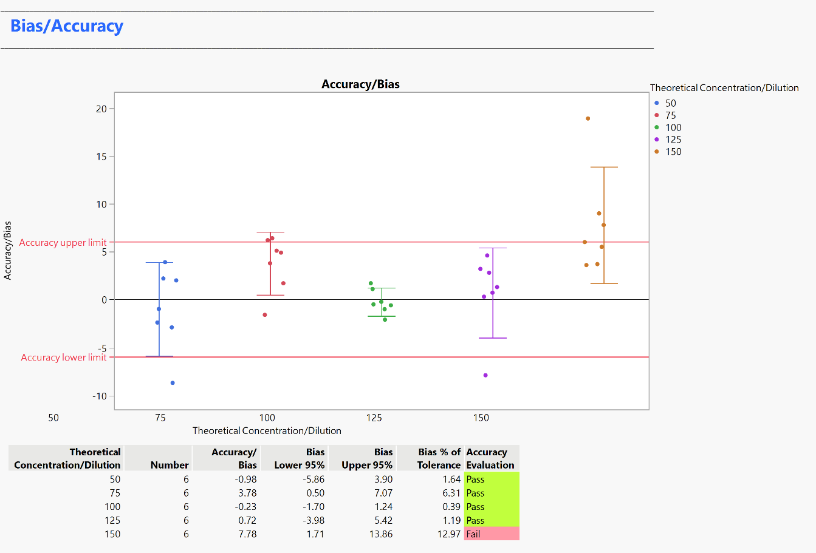

## Linearity

Linearity is visualized using a Bivariate fit with the theoretical concentration on the Y and relative potency on the X. This line if compared against a theoretical perfect fit with slope 1 and intercept 0. Range of linearity is then calculated from the studentized residuals of the Relative potency by the theoretical concentration. A quadratic curve is fitted to these and where the curve or its 95% confidence interval crosses +/- 1.96 determines the range of linearity. This is compared against Lower Linearity Limit * LSL and the Upper Linearity Limit * USL as specified in the launch dialog.

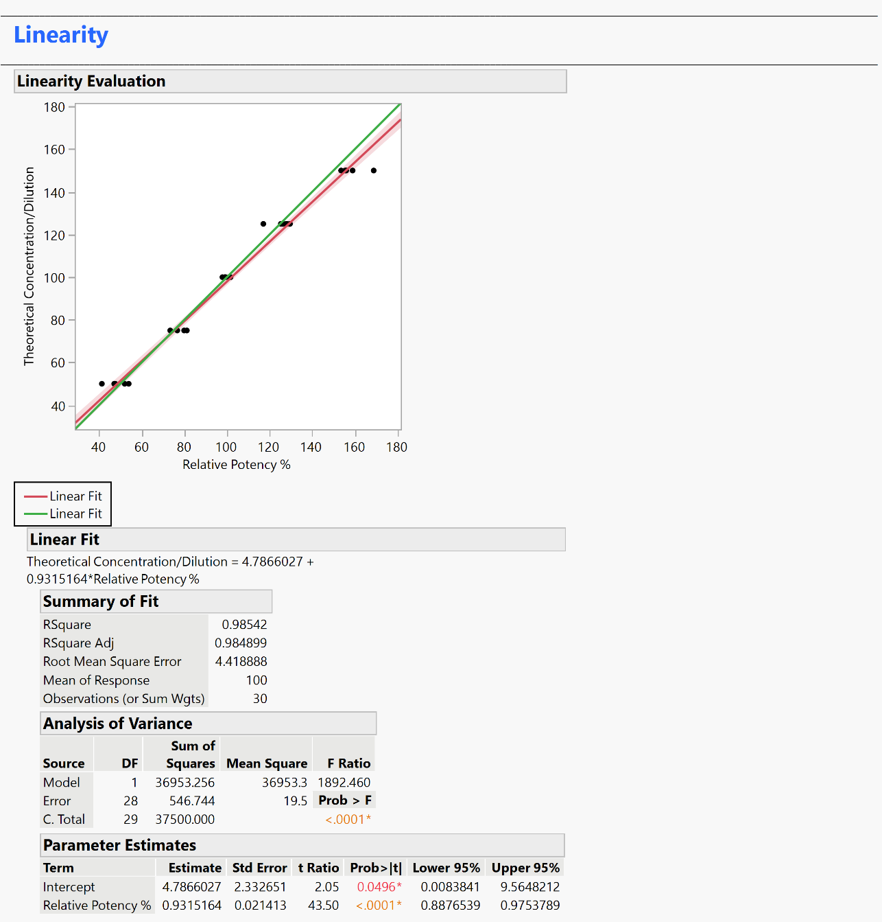

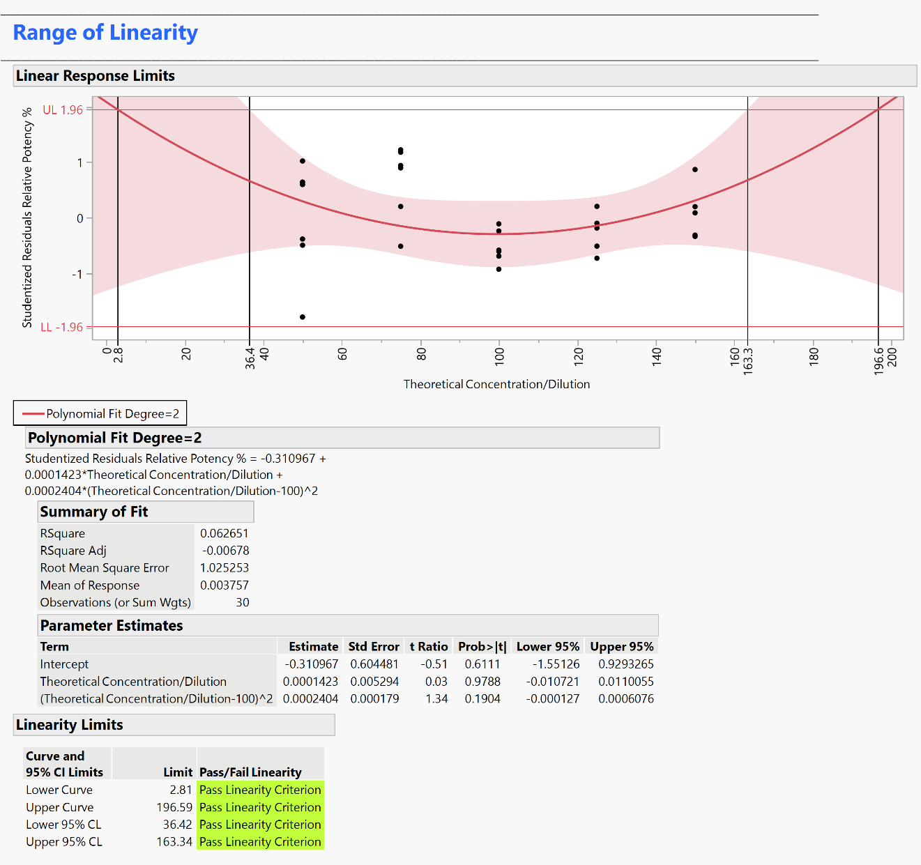

## Repeatability and Intermediate precision

Partition of Variation is used to calculate the variance components. The between components are reported, total within is used for Repeatability, the grand total is the Intermediate Precision. These are divided by tolerance (USL-LSL) and compared against the requirements as entered in the launch dialog.

Repeatability at different sample sizes are evaluated by using:

Intermediate precision at different sample sizes are evaluated by using:

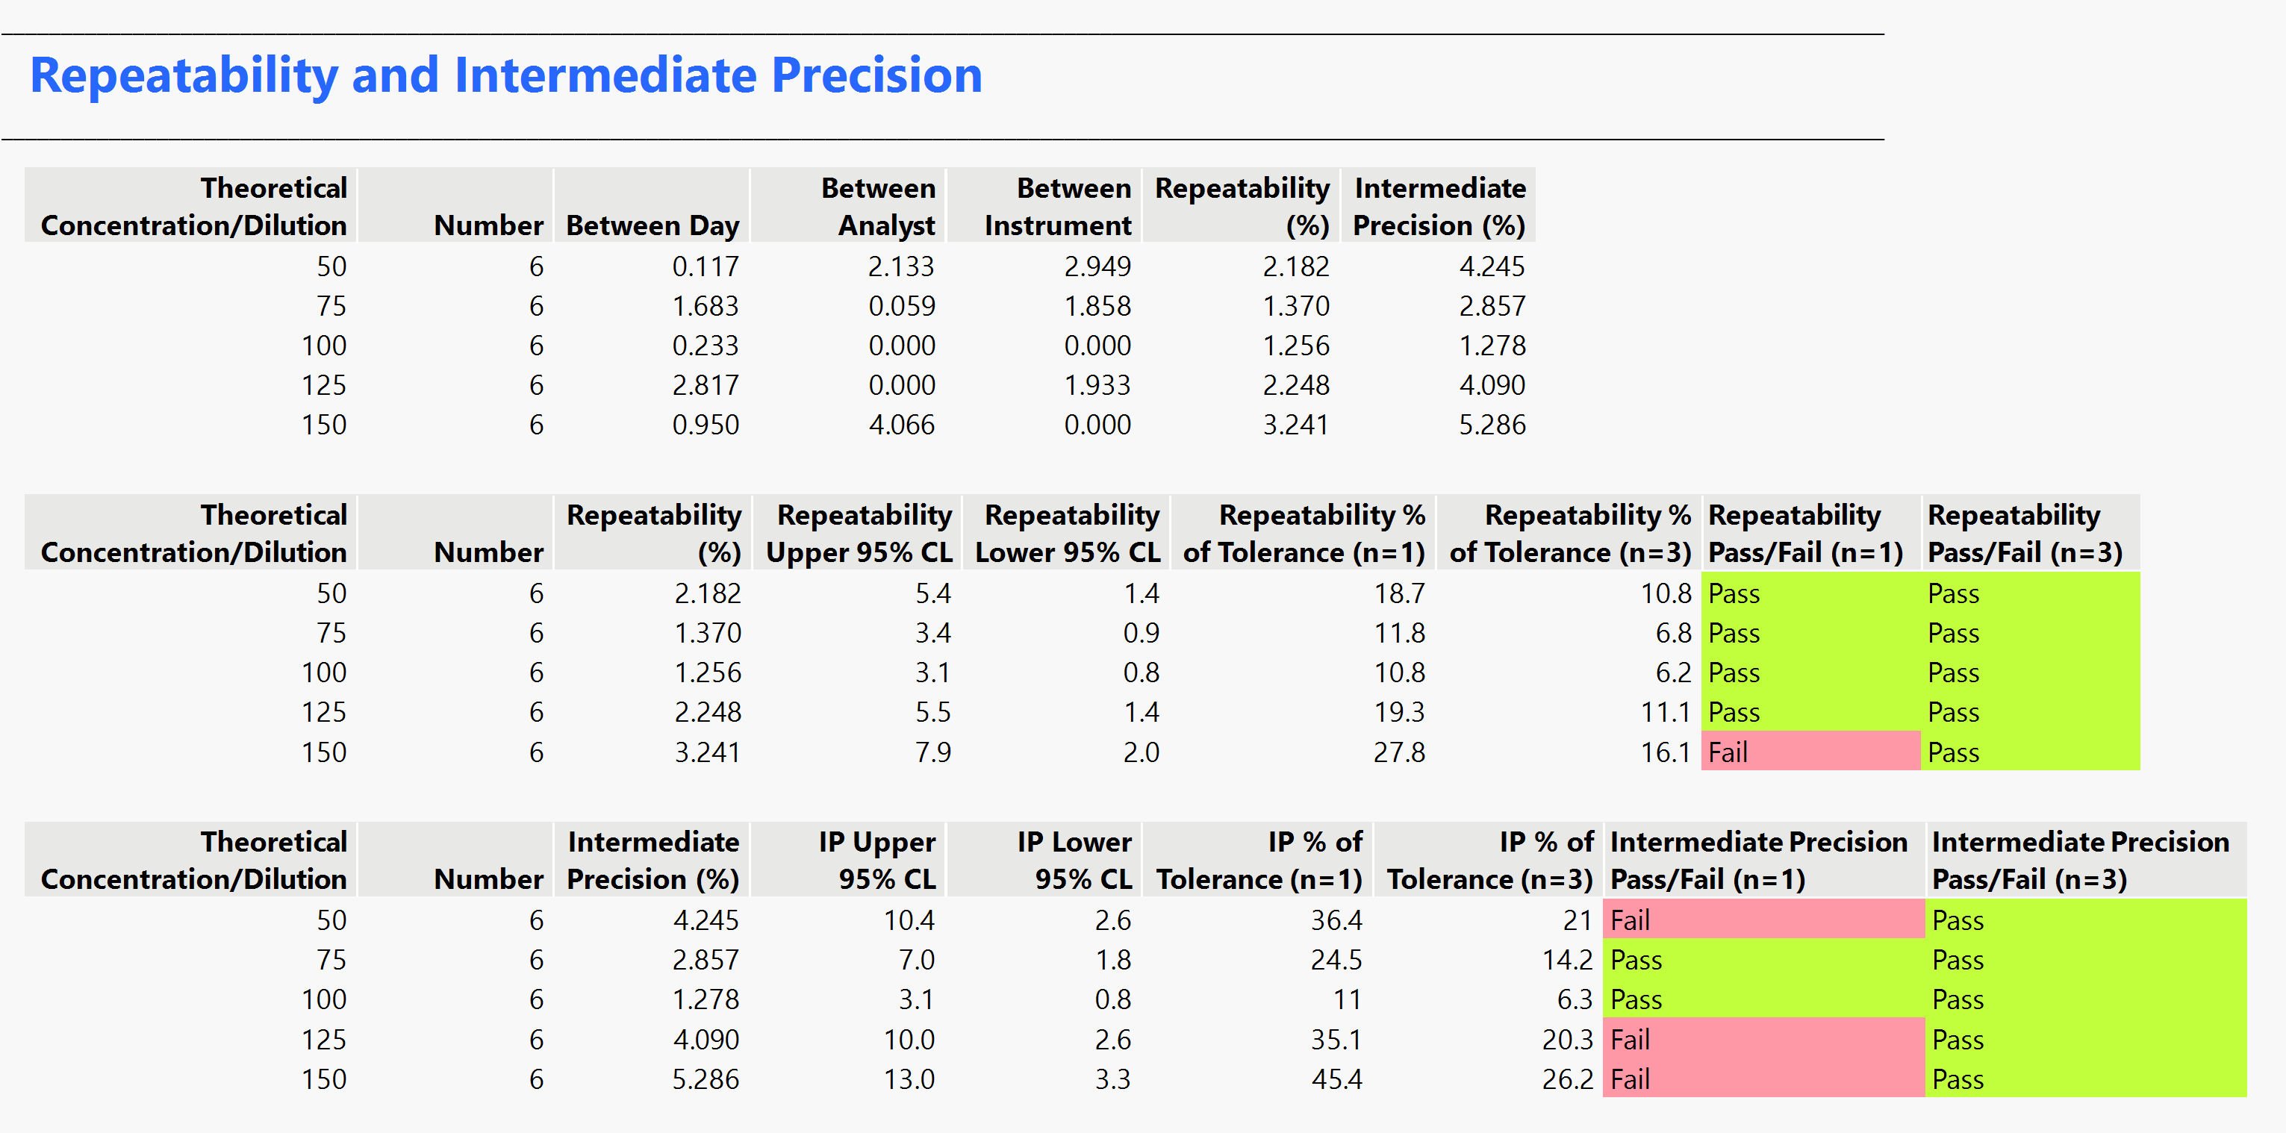

## Result

All values are summarized. The reported range is the range where the results are accurate, linear, repeatable, and the intermediate precision meets spec. This is reported both for the curve and for its 95% confidence interval.

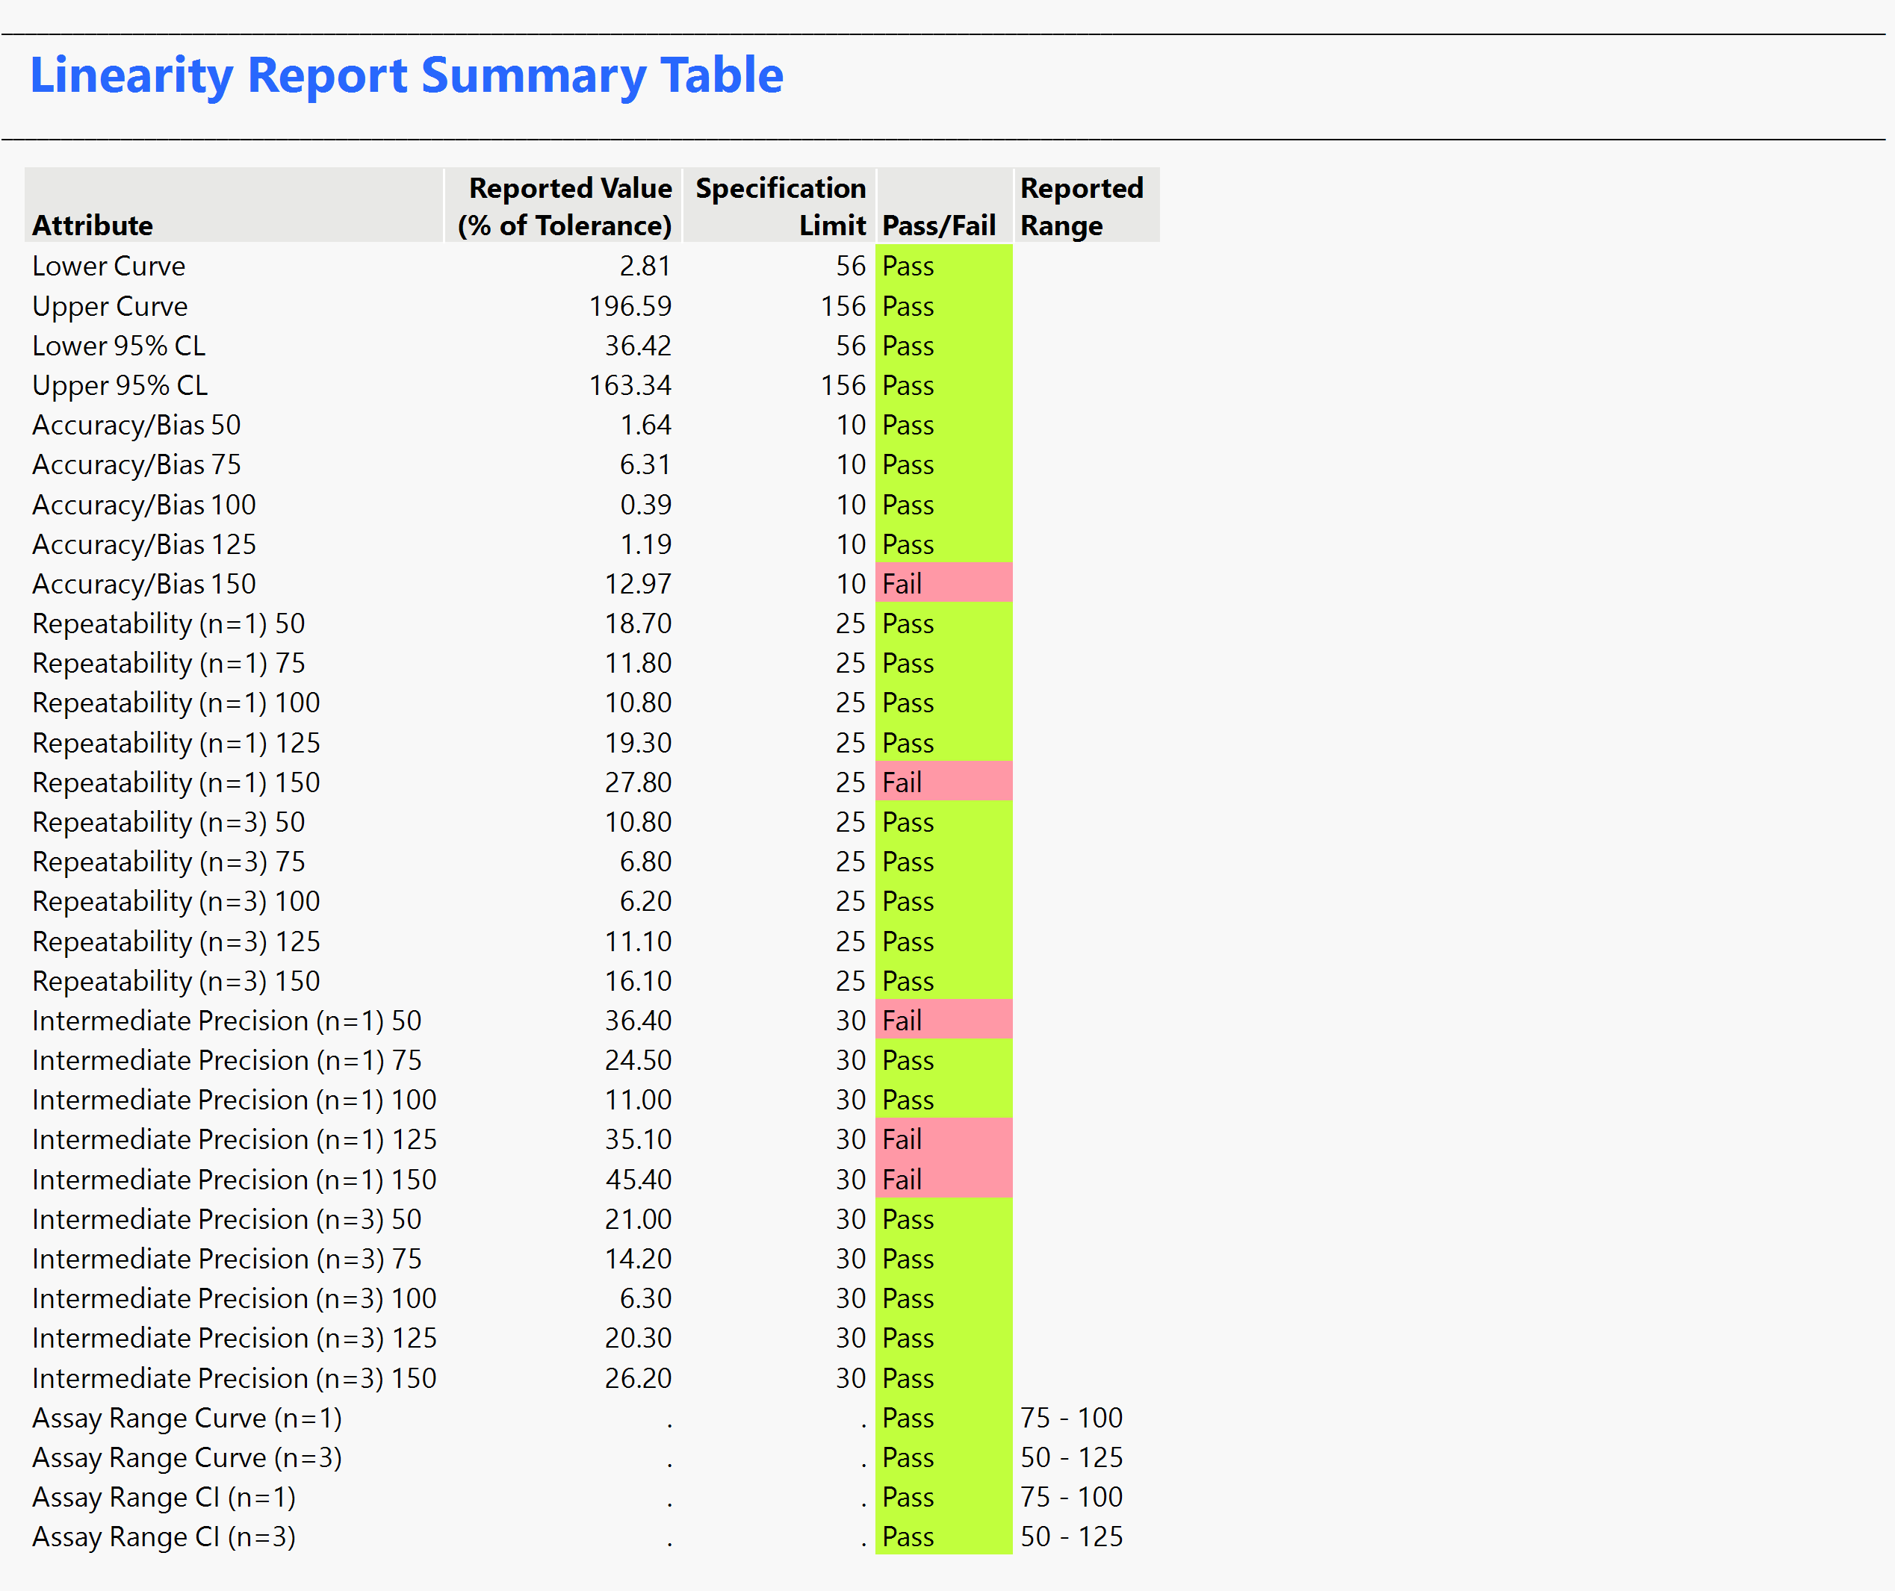

## Limit of Detection (LOD) and Limit of Quantitation (LOQ)

A table of means and Standard Deviations by concentration is generated using the oneway platform. If the lowest concentration has the smallest standard deviation, it is used for the calculation else the mean of all standard deviations is used. The calculations are:

If at launch the number of independent samples is set to N (N>1) then another set of columns is generated. The calculations are:

The outcome is presented as a table in the report:

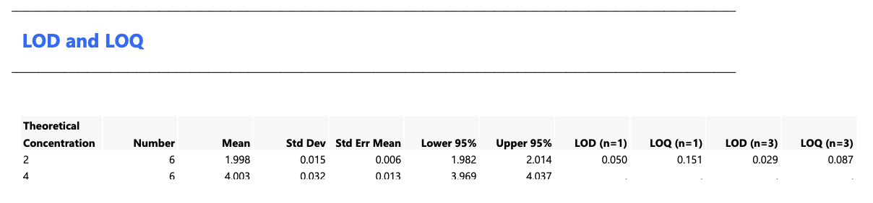

# Calculations for specificity

Each spiked sample is compared against the unspiked sample. Simple linear regression us used to fit a model of the relative potency with spiked/unspiked, concentration and the interaction between them. Effects test is used to determine interaction significance.

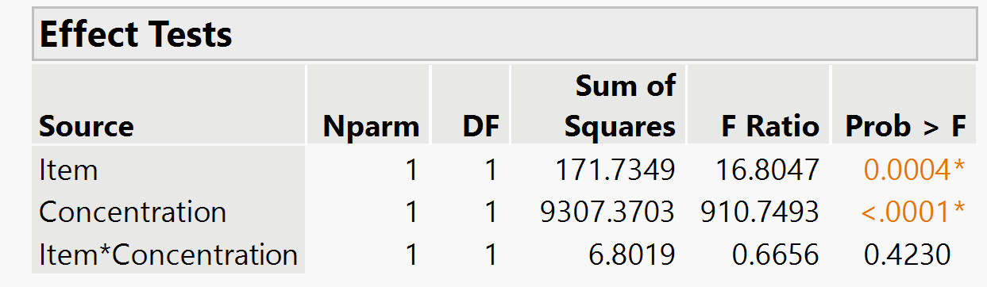

## Interaction significant

The model is refit with the theoretical concentration as a categorical factor. Then the Actual by Predicted Plot, Least Squares Means Plot of Spiked/Unspiked, the LSMeans Differences Student's t, the interaction Least Squares Means Plot are reported. The LSMeans Differences Tukey HSD is used as the result where the difference at each concentration divided by tolerance/margin/mean is compared against the spec entered in the launch dialog.

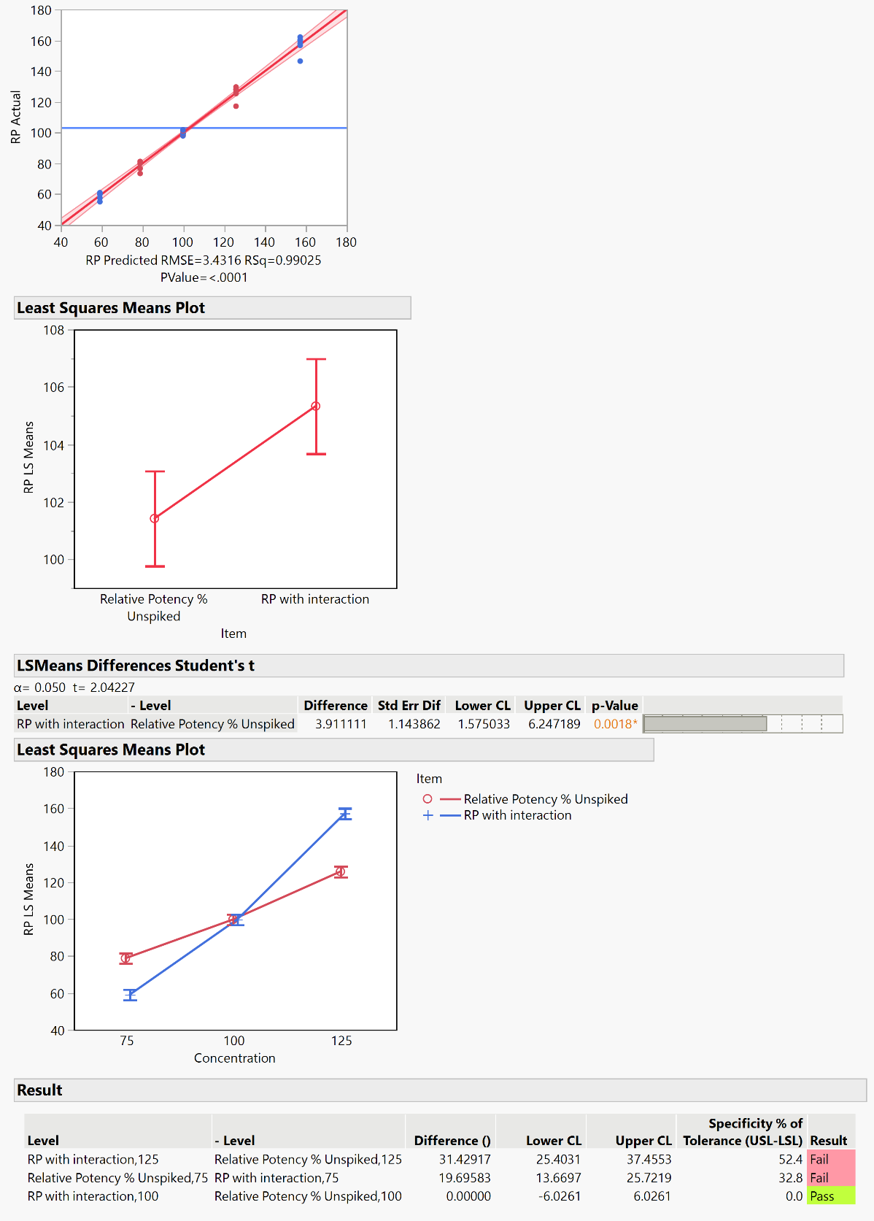

## Interaction not significant

The model is refit without the interaction effect. The Regression Plot, Least Squares Means Plot of Spiked/Unspiked are reported. The LSMeans Differences Student's t ordered differences report is used as the result where the difference at each concentration divided by tolerance/margin/mean is compared against the spec entered in the launch dialog.

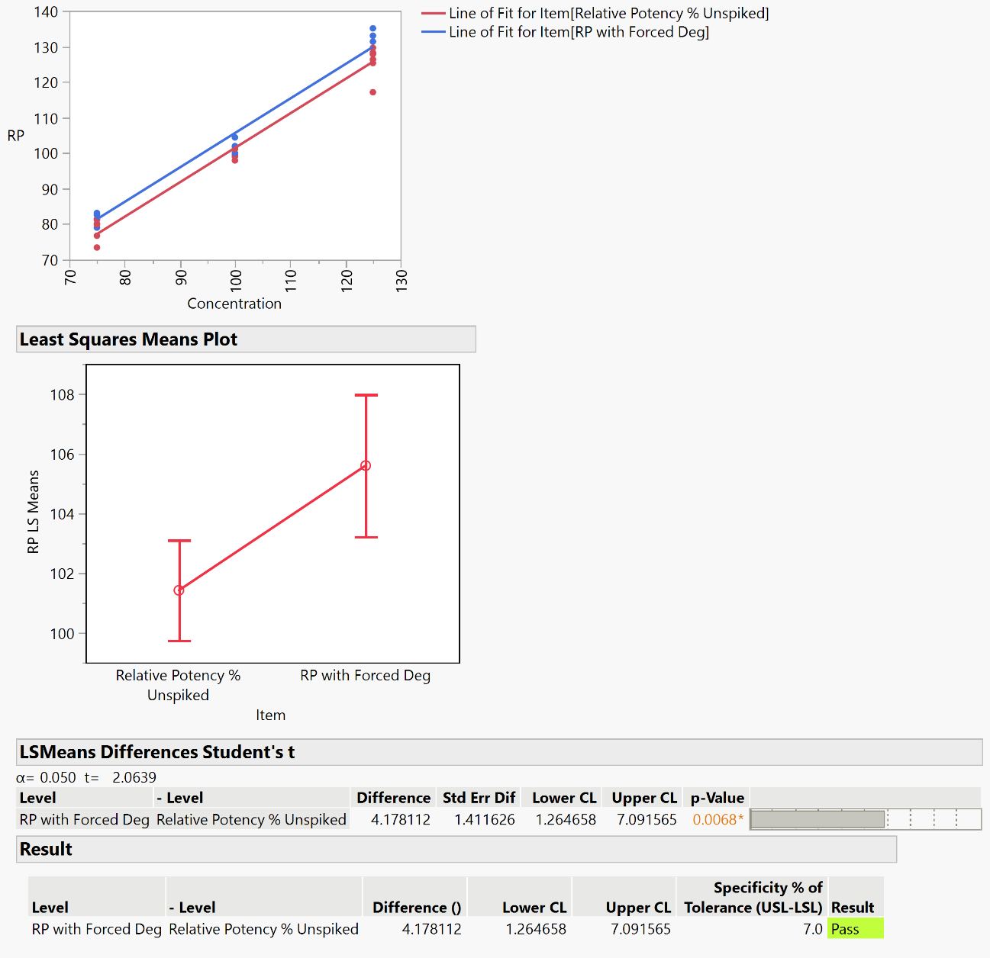

# Calculations for Stability

Three curves are fitted:

1. Linear
2. Exponential 3P
3. Square root(X)

The R-squareds and p-values of the slope, growth rate or Sqrt(X) term are captured and saved to a table. The highest R-squared is selected.

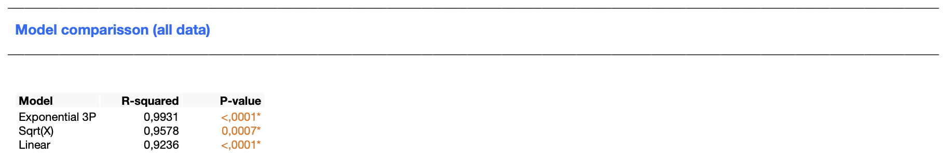

If outlier detection is turned on the selected model is fitted and externally studentized residuals are saved in case of square root (x) and linear model. For the Exponential 3P model the studentized residuals are saved. The absolute value of these are compared against the K sigma that was entered for outlier detection. If the residuals are to big, then the outlier is marked in the table and excluded from analysis.

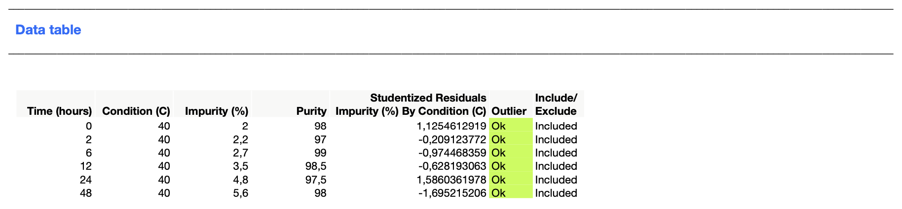

Finally the selected model is refit and the report from JMP is presented in the report

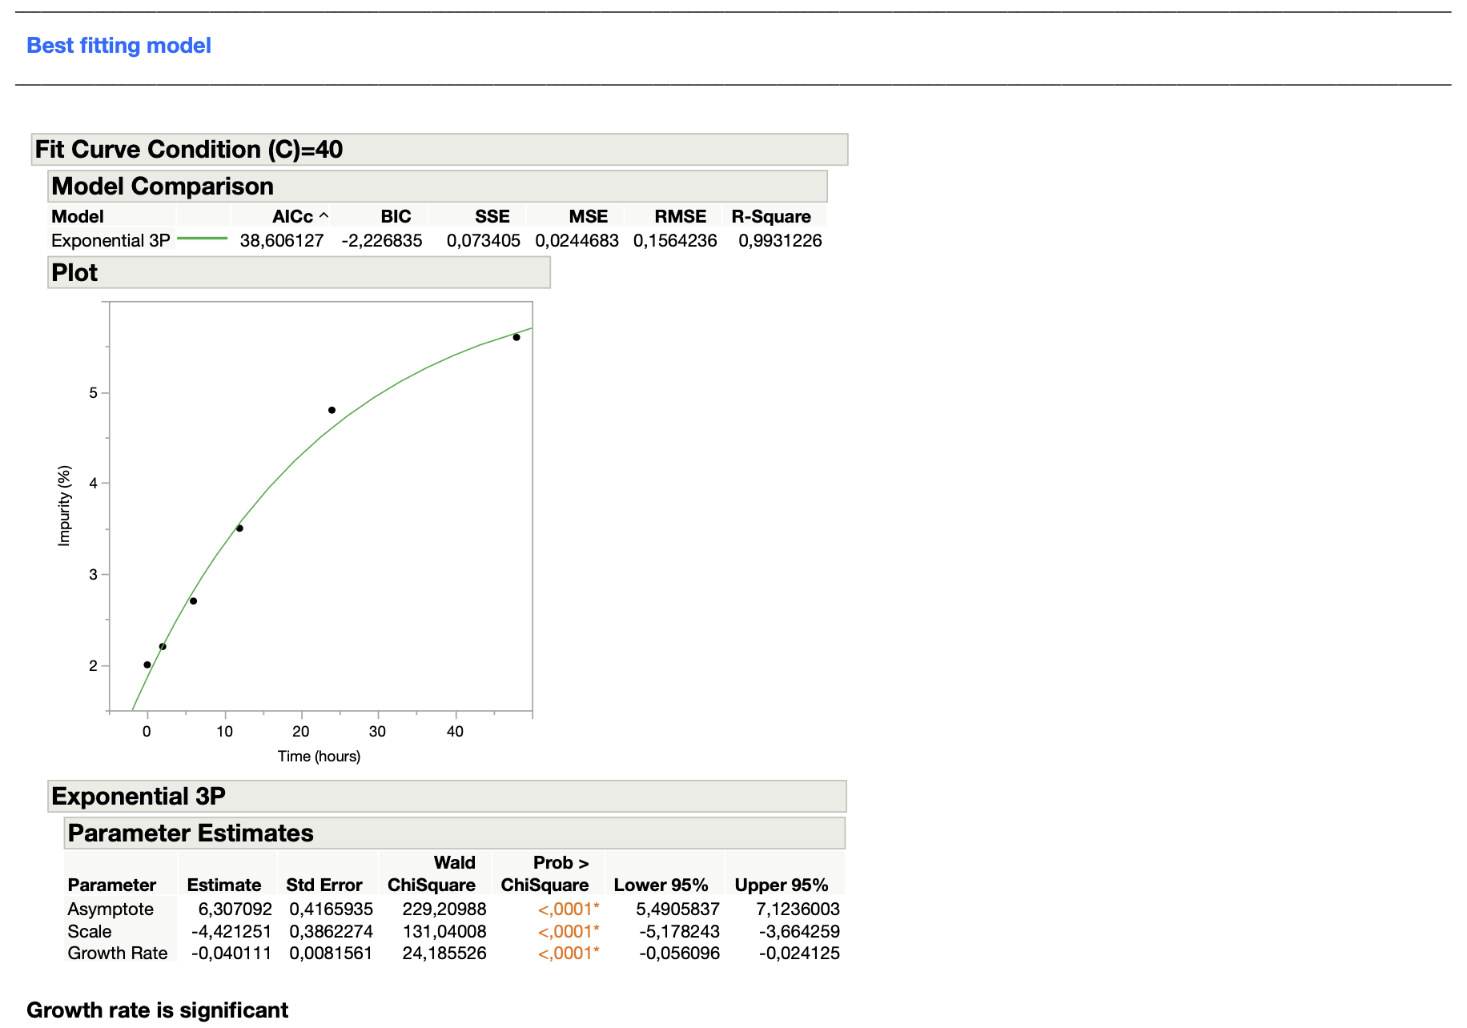

# Running the SAS/JMP Script

The following details the operation of the Method Validation Add-in. The add-in needs to be installed by running the .jmpaddin file, this will create a menu bar item called Method Validation which will contain menu items for linearity and specificity analysis.

## Running linearity analysis

Open a suitable data table with the study results in the following format:

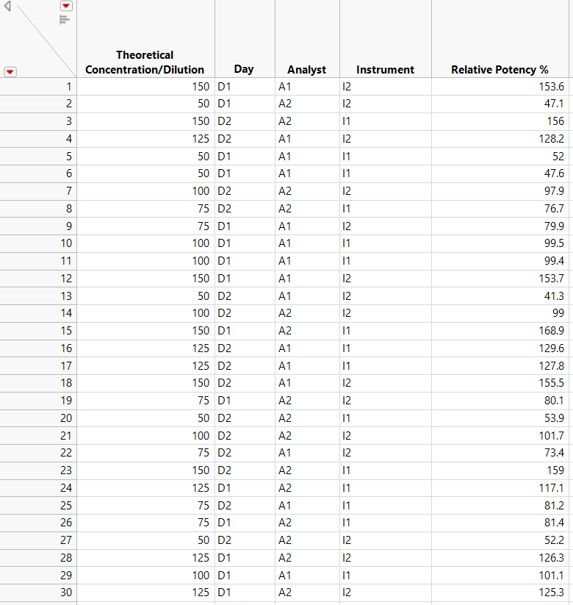

Navigate to Method Validation 🡪 Linearity Analysis and fill in the required fields like so:

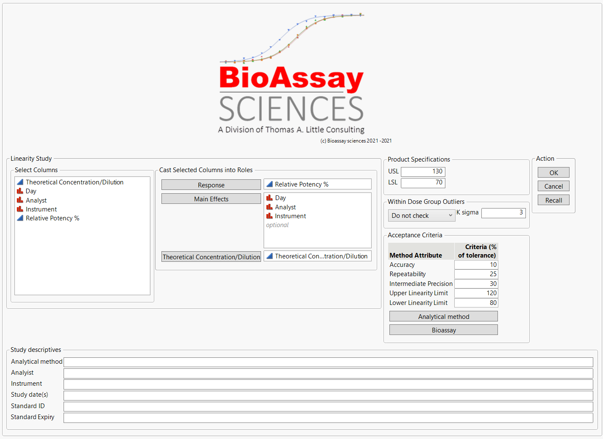

When completed, press Ok and the resulting journal and pdf version of the report will be stored in the folder where the data table is located. The filenames will be:

Data table name YYYY.MM.DDTHH.MM.SS.jrn

Data table name YYYY.MM.DDTHH.MM.SS.pdf

## Running specificity analysis

Open a suitable data table with the study results in the following format:

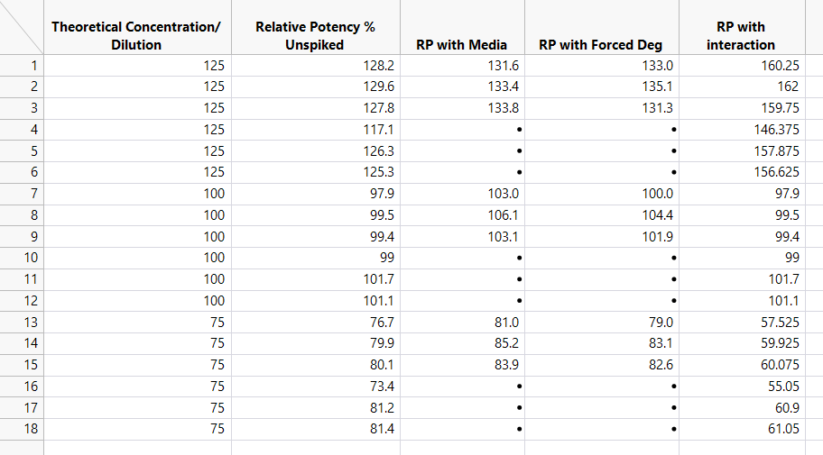

Navigate to Method Validation 🡪 Specificity Analysis and fill in the required fields like so:

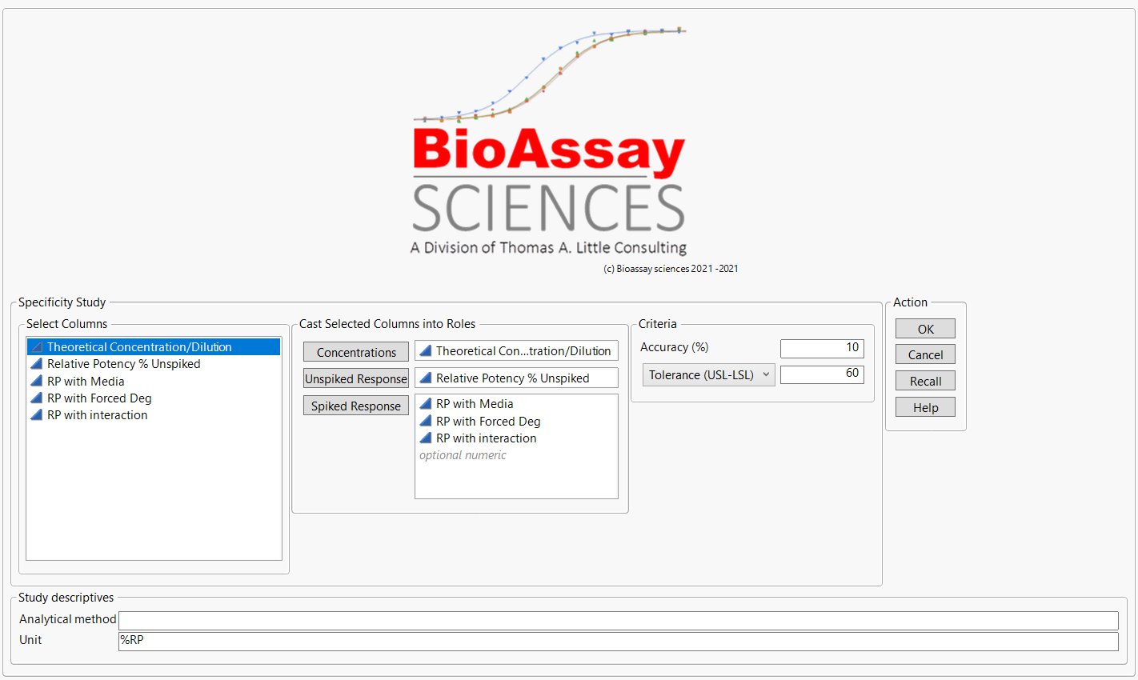

When completed, press Ok and the resulting journal and pdf version of the report will be stored in the folder where the data table is located. The filenames will be:

Data table name YYYY.MM.DDTHH.MM.SS.jrn

Data table name YYYY.MM.DDTHH.MM.SS.pdf